EENG 3920: Modern Communication Systems Design

# **Lab 5 - Experiment 7: Colpitts RF Oscillator Design**

Group 5

Victor Rodriguez (victorcuba92@gmail.com)

Mohammad Qawash (MohammadQawash@my.unt.edu)

John Rolfe (JohnRolfe@my.unt.edu)

Natalie Powers (NataliePowers@my.unt.edu)

Nathan Ruprecht (nathan.ruprecht@outlook.com)

**Date of Submission: 07 April 2016**

**Section 1**

**Introduction and Learning Objective**

EENG 3920 is the project design course for electronics courses. Students are required to design electronic communication systems with electronic devices such as MOS transistors, capacitors and resistors. The design and simulation tool is NI ELVIS platform. Topics include LC circuits and oscillators, AM modulation, SSB communications, and FM modulation. At the end of the class, the student should be able to: Understand fundamental concepts and circuits used in communication systems; Describe principles and theory of various communication techniques such as AM, FM, and SSB; Conduct effective analysis and interpretation of the experiments; Demonstrate the ability to identify, analyze, and solve technical problems; Creatively apply the course topics to designs; Simulate and analyze advance electronics circuits with NI ELVIS instruments and other test equipment.

For this experiment we investigated the behavior of a negative clamper, studied class C bias and amplification, and understood the theory of frequency multiplication.

**Safety guidelines**

As mentioned in the lab procedures, safety is extremely important in the lab. In the event of electrical fire, the session 1 lecture note states to use the fire extinguisher, located at the front of the lab, then to vacate the lab, close the door and ring the fire alarm.

**Section 2 / 3**

**Theoretical Background**

In this lab, we designed, built and tested a Colpitts oscillator. As in the oscillators of Experiments 5 and 6, Barkhausen criteria must be met for oscillations to occur. Specifically, the product of the loaded voltage gain of the active device’s stage and the attenuation of the feedback network must be equal to or slightly larger than unity to sustain oscillations resulting from an undistorted sinusoidal output signal.

**Exercises**

Procedure:

First, we had to pick the values for 3 resistors and 2 capicitors in order to satisfy the AC and DC requirements. For the DC design, VBE was assumed to be 0.5V, IE is approximately 3.75mA, the current through R1 and R2 is approximately one-tenth the value of IE, VCE is 5.5v and assuming the 27-mH inductor is ideal.

For the AC design, we were told to pick values for C1 and C2 to achieve a value of B such that Av*B=10 and to cause the frequency of oscillation to be 1.8MHz plus or minus 200kHz.

After we got standard values that would work, we built the circuit and hooked it up to the function generator with the frequency set to 1.8MHz and a 20mVP-P applied at TP2. The optimal frequency to maximize the maplitude of our output was at **1.46MHz**. At this frequency, we tested different pointS in our circuit (Step 5 of the procedure) and recorded the results:

|  |  |  |  |
| --- | --- | --- | --- |
| Voltage | Amplitude | Frequency | Phase |
| VF | 1V | 1.46MHz | 180 |
| VC | 1.15V | 1.46MHz | 180 |
| VF | 0.5V | 1.46MHz | 100ns |

The next part of the lab was to go back and clarify that AV*B exceeds unity. Since AV= VC / B, AV*B=VC which is 1.15 so we exceeded 1. The rest of the lab was troubleshooting problems in case something went wrong or in case the signal was distorted. Everything on our circuit worked fine with no complications.

**Section 4**

**Conclusion**

In this lab, we designed, built and tested a Colpitts oscillator. As in the oscillators of Experiments 5 and 6, Barkhausen criteria must be met for oscillations to occur. Specifically, the product of the loaded voltage gain of the active device’s stage and the attenuation of the feedback network must be equal to or slightly larger than unity to sustain oscillations resulting from an undistorted sinusoidal output signal.

Follow up Questions:

Our final schematic with values:

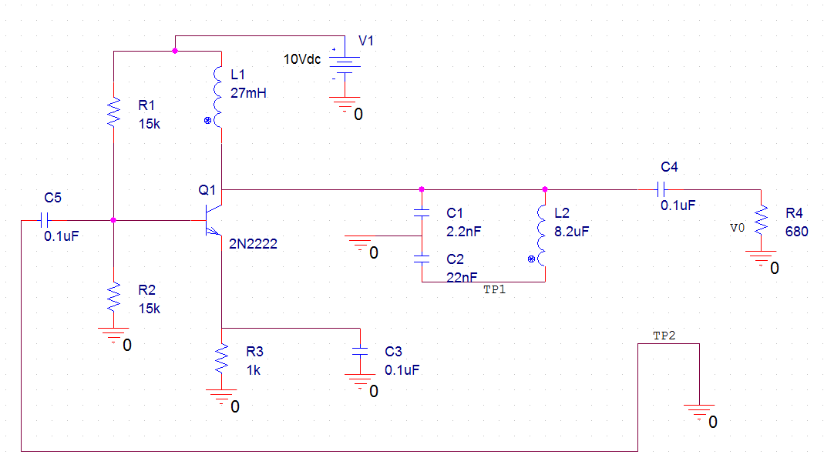

DC Equivalent: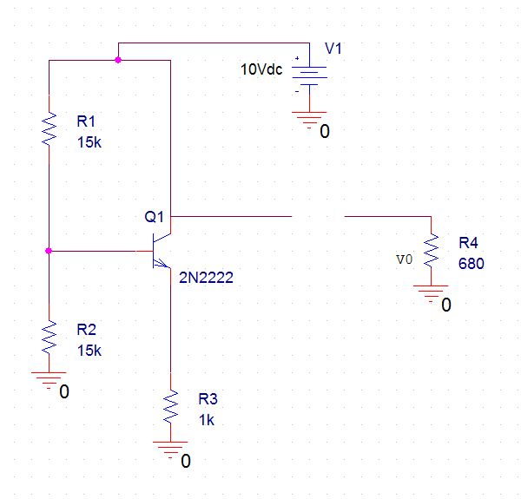

AC Equivalent:

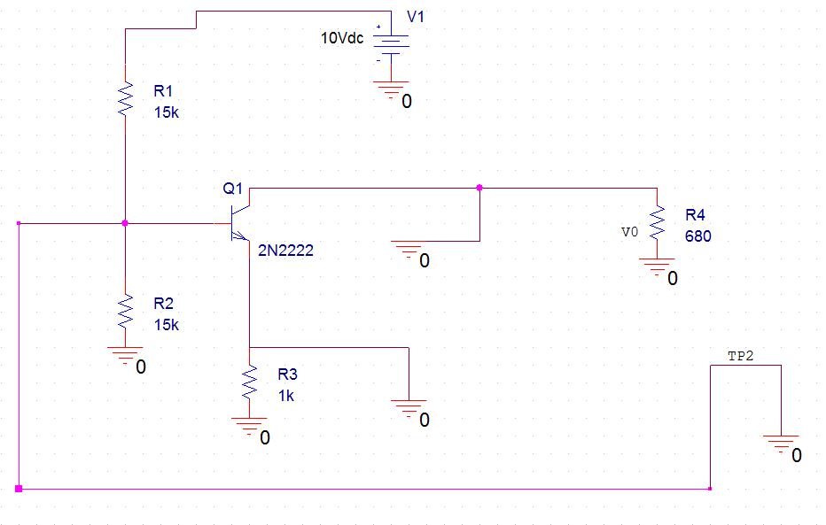

# **References**

Agilent Technologies, 2007, *Agilent 34401A 6 ½ Digit Multimeter, User’s Guide*.